

See discussions, stats, and author profiles for this publication at: [https://www.researchgate.net/publication/324517934](https://www.researchgate.net/publication/324517934_ONLINE_VEHICLE_PARKING_RESERVATION_SYSTEM?enrichId=rgreq-b8171336deaaf25c7ae133c1a68c714d-XXX&amp;enrichSource=Y292ZXJQYWdlOzMyNDUxNzkzNDtBUzo2MTUyNTQxNjE2NDU1NjlAMTUyMzY5OTQzMTQyNQ%3D%3D&amp;el=1_x_2&amp;_esc=publicationCoverPdf)

[ONLINE VEHICLE PARKING RESERVATION SYSTEM](https://www.researchgate.net/publication/324517934_ONLINE_VEHICLE_PARKING_RESERVATION_SYSTEM?enrichId=rgreq-b8171336deaaf25c7ae133c1a68c714d-XXX&amp;enrichSource=Y292ZXJQYWdlOzMyNDUxNzkzNDtBUzo2MTUyNTQxNjE2NDU1NjlAMTUyMzY5OTQzMTQyNQ%3D%3D&amp;el=1_x_3&amp;_esc=publicationCoverPdf)

**Research Proposal** · April 2018

DOI: 10.13140/RG.2.2.12134.32325

CITATIONS

0

READS

15,511

**1 author:**

[Ndayisaba Corneille](https://www.researchgate.net/profile/Ndayisaba_Corneille?enrichId=rgreq-b8171336deaaf25c7ae133c1a68c714d-XXX&amp;enrichSource=Y292ZXJQYWdlOzMyNDUxNzkzNDtBUzo2MTUyNTQxNjE2NDU1NjlAMTUyMzY5OTQzMTQyNQ%3D%3D&amp;el=1_x_5&amp;_esc=publicationCoverPdf)

[International Health Sciences University (IHSU)](https://www.researchgate.net/institution/International_Health_Sciences_University_IHSU?enrichId=rgreq-b8171336deaaf25c7ae133c1a68c714d-XXX&amp;enrichSource=Y292ZXJQYWdlOzMyNDUxNzkzNDtBUzo2MTUyNTQxNjE2NDU1NjlAMTUyMzY5OTQzMTQyNQ%3D%3D&amp;el=1_x_6&amp;_esc=publicationCoverPdf)

**1** PUBLICATION **0** CITATIONS

[SEE PROFILE](https://www.researchgate.net/profile/Ndayisaba_Corneille?enrichId=rgreq-b8171336deaaf25c7ae133c1a68c714d-XXX&amp;enrichSource=Y292ZXJQYWdlOzMyNDUxNzkzNDtBUzo2MTUyNTQxNjE2NDU1NjlAMTUyMzY5OTQzMTQyNQ%3D%3D&amp;el=1_x_7&amp;_esc=publicationCoverPdf)

**Some of the authors of this publication are also working on these related projects:**

 ONLINE VEHICLE PARKING RESERVATION SYSTEM [View project](https://www.researchgate.net/project/ONLINE-VEHICLE-PARKING-RESERVATION-SYSTEM?enrichId=rgreq-b8171336deaaf25c7ae133c1a68c714d-XXX&amp;enrichSource=Y292ZXJQYWdlOzMyNDUxNzkzNDtBUzo2MTUyNTQxNjE2NDU1NjlAMTUyMzY5OTQzMTQyNQ%3D%3D&amp;el=1_x_9&amp;_esc=publicationCoverPdf)

All content following this page was uploaded by [Ndayisaba Corneille](https://www.researchgate.net/profile/Ndayisaba_Corneille?enrichId=rgreq-b8171336deaaf25c7ae133c1a68c714d-XXX&amp;enrichSource=Y292ZXJQYWdlOzMyNDUxNzkzNDtBUzo2MTUyNTQxNjE2NDU1NjlAMTUyMzY5OTQzMTQyNQ%3D%3D&amp;el=1_x_10&amp;_esc=publicationCoverPdf) on 14 April 2018.

The user has requested enhancement of the downloaded file.

**ONLINE VEHICLE PARKING RESERVATION SYSTEM**

**A CASE STUDY: PEOPLE’S PARK KYEBANDO,KAMPALA UGANDA**

**BY NDAYISABA CORNEILLE**

**13A/KUL/BCSIT/0114**

**A PROJECT REPORT SUBMITTED TO THE SCHOOL OF COMPUTER SCIENCE AND INFORMATION TECHNOLOGY IN PARTIAL FULFILLMENTOF REQUIREMENTSFOR THE AWARD**

**OF A DEGREE IN COMPUTER SCIENCE AND INFORMATION TECHNOLOGY OF KAMPALA UNIVERSITY**

**MAY, 2016**

# Declaration

I, **NDAYISABA CORNEILLE** of REG 13A/KUL/BCSIT/0114, hereby declare that this is my original work except where references have been made, and has never been submitted for an award to this Institution, or any other institution of higher learning.

### Researcher

Signature: .................................................... Date: ............/..................../............................

# Approval

I have supervised this report and it’s now ready to be submitted for the award of a Degree in computer science and information Technology.

Signature: .................................................... Date: ............/..................../ 20.........

### Mr. KATE REGGA AXAM

# Dedication

I would like to dedicate this project report to my entire family most especially to my dad Mr Njezi Andrew And mum Mrs Niyitegeka Therese and also my Brothers Mr Kedi Lisala ,Mr Robert for the financial support they have rendered to allow me pursue this course and also to enable me to do my research smoothly.

# List of figures

FIGURE 1: BELOW SHOWS TWO FLOW CHART THAT DEMONSTRATES HOW THE SYSTEM WORKS 15

FIGURE 2: ARCHITECTURAL DESIGN OF THE SYSTEM 16

FIGURE 3: SHOWS AN ENTITY RELATIONSHIP DIAGRAM OF THE SYSTEM 17

FIGURE 4: SHOWS THE PIE CHART FOR NUMBER OF CLIENTS WHO BOOK THE PARKING ONLINE 20

FIGURE 5: SHOWS THE INTERFACE OF SYSTEM LOGIN 21

FIGURE 6: SHOWS THE WEB APPLICATION IN MOZILLA FIREFOX 22

# List of Tables

TABLE 1: MINIMUM HARDWARE REQUIREMENTS 12

TABLE 2: MINIMUM SOFTWARE REQUIREMENTS 13

TABLE 3:DESCRIBES THE PARKING TABLE 14

TABLE 4: DESCRIBES THE USER TABLE 15

TABLE 5:DESCRIBES THE ADMIN TABLE 17

TABLE 6: DESCRIBES THE CONTACT TABLE 17

# List of Acronyms

ATCM………………………………………………**A**ssociation of **T**own & **C**ity **M**anagement ISO………………………………………………… International Standards Organization PPK………………………………………………….People’s Parking Kyebando OVPRS………………………………………………Online Vehicle Parking Reservation System WWW ………………………………………………World Wide Web

PHP .…………………………………………….. Hypertext Preprocessor SQL ……………………………………………… Structural Query Language CSS…………………………………………………..Cascading Style Sheets

RDBMS ……………………………………………..Relation Database Management System GUI …………………………………………………Graphical User Interface

HTTP …………………………………………………Hypertext transfer protocol ERD …………………………………………………..Entity relational diagram DFD ………………………………………………….Data flow diagram

rd………………………………………………………..road KCCA……………………………………………………Kampala Capital City Authority VGA……………………………………………………..Video Graphical Adapter

# Table of Contents

Declaration ii

Approval iii

Dedication .......................................................................................................................................................

List of figures...................................................................................................................................................

List of Tables iii

List of Acronyms iii

Table of Contents iv

Chapter One 1

* 1. Introduction 1
  2. Background of the study 1
  3. Statement of the problem 1
  4. Objectives of the Study 2
     1. Main Objectives 2
     2. Specific Objectives 2
  5. Research Questions 2
  6. Scope of the Study 3
     1. Geographical Scope 3
     2. Time Scope 3
  7. Significance of Study 3

Chapter Two: 4

Literature Review 4

* 1. Introduction: 4
  2. Online vehicle parking reservation system 4
  3. The way drivers locate and reserve parking places 5
  4. Improvement of the current car parking reservation system 5
  5. The current systems used in parking places 6
  6. The need to research about Vehicle park reservation system 7

Chapter Three: 8

Methodology 8

1. Introduction 8

3.1 Study Area & Population 8

* + 1. Interviews 8
    2. Observations 9
  1. System analysis 9
  2. System design and Implementation 9
     1. System design 9
     2. System Implementation 10

3.4 System Testing and Validation 10

Chapter Four 11

System Study, Design and Implementation 11

* 1. System Study 11
     1. Current Vehicle Parking Reservation System 11
     2. Weaknesses of the Current System 11

4.1.2 Strength of the Current System 12

* 1. System Requirements 12
     1. User Requirements 13
     2. Functional Requirements 14
     3. Non Functional requirements 14
  2. System Design 14
     1. System Story 14
     2. Architectural Design of the System 16
     3. Entity Relationship Diagram 17
     4. Database Schemas 18

Chapter Five 23

Summary, Recommendation and Conclusion 23

5.1 Introduction 23

* 1. Recommendations 23
  2. Conclusion 24

References 25

Appendices 26

Appendix 1: The project estimate. 26

Appendix 2: Project work plan schedule (2016) 27

Appendix 3: Screen shot for the interface of system administrator where the managing users are taken place 28

Appendix 4: Sample code for user sign up in back end (php) 28

Appendix 5: Sample code for user sign up in front end 29

**Abstract**

The Online Vehicle Parking Reservation System (OVPRS) is a system that enables customers/drivers to reserve a parking space. It also allows the customers/drivers to view the parking status at kyebando people’s park. It was developed because the congestion and collision of the vehicle, the system was developed for Kyebando People’s Park located in Kyebando Therefore the project aimed at solving such problems by designing a web based system that will enable the customers/drivers to make a reservation of available parking space at people’s park.

The requirements for the developed system were collected using observation and interviewing the customer and staff member from Kyebando people’s park. The data from interviews was analyzed using Microsoft Excel so as to come up with the functional, non- functional and system requirements. These requirements were later used to design the system by creating data flow diagrams and entity relationship diagrams. The designed system was implemented using different development tools which include HTML for creating interfaces, CSS for styling wed pages

,JavaScript, and Jquery for dynamism in the web pages and as an input validation tool.XAMMP was used to build the database and PHP used as a server side scripting language to connect the user interfaces to the database. The system was tested by the researchers for errors.

### Introduction

# Chapter One

The parking place is very important all over the world especially in the cities of the countries. Every day thousands of car drivers spend a lot of the time to find where to park. The result of this situation is theft in urban areas, increasing traffic congestion and frustration of drivers. In order to solve this problem, the implementation of Online Vehicle Park Reservation System in this city for managing parking places is mandatory. It will allow the drivers to Reserve a parking place on the Platform of People’s Park Kyebando (PPK) anytime, anywhere.

This chapter gives an overview of the background of the study, statement of the problems, objectives of the study, research questions, scope of the study and significance of the study.

### Background of the study

People’s Park Kyebando is located in Kampala district along Kampala –Gayaza rd and was licensed by KCCA in 2009. it‘s located 1 mile from Kalwere round about, People’s Park Kyebando is constructed on 1 Acre of land (measurements 100ft-100ft) in kyebando village, it provides enough space for its well-wishing customers, It is equipped with high maximum security coupled with an electric fence , four gun men from a well training security company and well trained bull dogs have been also used to control trespassing within the People’s Park and with this maximum security, expenses like compensation of customers’ lost vehicles are brought down.

### Statement of the problem

People’s Park Kyebando had challenges concerning its safety of data in the store since they currently use paper based system,physical struggle for parking by drivers, wastage of time, congestion and collision. There was also a problem of monitoring the profit made for the company where by the company was losing money to its workers who receive the money (fraud).This system majorly solved the congestion, collision and save time during parking activities.

### Objectives of the Study

### Main Objectives:

To enable drivers to locate and reserve a parking place online through accessing it on web platform.

### Specific Objectives:

* To establish possible solutions to improve on the current Vehicle Parking Reservation system
* To design and implement Online Vehicle Parking Reservation system
* To make a good research about People’s Park and gather all necessary information that helped in designing the new parking reservation system.

### Research Questions

* How are drivers able to locate and reserve parking place at People’s Park?
* How will the improvement of the current vehicle parking reservation system be achieved?
* What is the current parking system used by People’s Park?
* Why is there a need to research about vehicle parking reservation system?
  1. **Scope of the Study**

### Geographical Scope

Online Vehicle Parking Reservation System is a web application where by research about it was conducted within PPK located at Gayaza -Kampala Rd, Kampala, Uganda on the following map coordinate Lat Lng(0.358657, 32.5735641).

### Time Scope

The study was conducted for duration of four month from May-August 2016 from the stage of analysis, data collection and system development, for the purpose of collecting righteous information to enable me develop the system.

### Significance of Study

* Due the increased transmission in information technology this makes PPK to change from manual and local Vehicle Parking Reservation System to computerized and Online Vehicle Parking Reservation system was used to make management, registration and booking easier.
* The research has helped to minimize paperwork, errors made from the reservation office like miss spelling the number plate, vehicle model, time wastage, delays and congestion at the reservation office.
* The study was also useful to the researcher in the way that it helped him in putting the acquired knowledge in Computer Science into practical perspective.
* This research shall also be helpful to the government to get relevant information and make polices for such organizations and also encourage others to adopt.

# Chapter Two: Literature Review

### Introduction:

This chapter is about the thoughts and views of other scholars in relation to the topic identified by the researcher therefore; the purpose of the study is to review previous studies in relation to the topic under my study. It also looks at that systems which have been developed by other researchers.

* 1. **Online vehicle parking reservation system**

According to **Shem, S, S.Park and S.Hong (2006)** online vehicle parking reservation system (OVPRS) is web-based used to reserve a park and data processing system. Drivers are no longer disturbed to park their vehicle since the system generate the parking lot number on OVPRS platform. A system requirement of OVPRS requires a currently supported version of Microsoft internet explorer or Firefox. Access to confidential data in OVPRS is secured using 12 bit secure socket layers (SSL) ORS also requires cookies’ and scripting of java applets to be enabled

### Information Systems (IS)

An information system (IS) is any system that converts data into useful information. Information systems can be used to support strategy at the organization of any type. Many definitions also specify that an Information system involve the use of Information Technology (IT).

O’Brien (1998), defines Information system as an organized combination of people, hardware, software, communications networks, and data resources that collects, transformations, and disseminates information in an organization. Support of managerial decision-making is one of the vital roles performed by an information system in any type of organization.

According to Schulte’s and Sumner (1995), information systems consist of components that interact to achieve the objective of providing information about day-to-day activities that managers can use to control business operations. Information systems can also be designed to provide information to enable managers to allocate resources and establish long-range business plans. Information system is a complete apparatus for handling all aspects of information within an

organization. It includes everything from the completely human-oriented aspects of information to the technologically oriented aspects (French, 2001). A system is a group of interrelated components working together towards a common goal by accepting inputs and producing outputs in an organized transformation

**4 Jun 2005, John Willey and sons** printed an acid –free paper covering Geographic information systems, student’s registration event record.

According to ***Schulte’s and Sumner (1995)***, information systems consist of components that interact to achieve the objective of providing information about day-to-day activities that managers can use to control business operations. Information system is a complete apparatus for handling all aspects of information within an organization. It includes everything from the completely human-oriented aspects of information to the technologically oriented aspects (**French, 2001**). A system is a group of interrelated components working together towards a common goal by accepting inputs and producing outputs in an organized transformation

## The way drivers locate and reserve parking places

The Drivers especially those who may need get the parking spaces may find it impossible to access it since there could be other vehicles blocking the way and yet they have to hurry to book for parking spaces. This is because of using paper based which is unsecure and needs self-contact to reserve for parking and it’s also time consuming, to design online vehicle parking reservation system will provide better efficiency in locating parking space and paying for it.

According to **Whapples (2005),** online vehicle parking reservation will be also much faster, easier on both sides (means clients and company). The time taken to serve a client is significantly reduced since even the payment is done online .On company side this system will help their records (such as clients’ details) to keep it in a secure way.

## Improvement of the current car parking reservation system.

From a literature studies, researcher found that **Kianpisheh et al., (2012)** proposed a new parking system called online vehicle park reservation system (0VPRS), which assists the driver in finding a vacant place in a short time. ‘The system is designed for a two-level for booking Vehicle Park with 100 parking spaces. The most essential features of the OVPRS is to detect and present available parking spaces, provide payment facilities and various kinds of parking spaces (vacant

and reserved). After finding the preferable space the drivers will follow the procedures for booking if there is a vacant space. In addition, the driver should also notice the color, which determines the status of the place: green means the space is available and yellow means it has been reserved. The green color will automatically change to yellow when a driver booked the available space. This system will probably reduce time, cost and effort for finding a vacant place in PPK. They believe both car park operators and drivers will benefit from the system as parking spaces are easily acquired and parking space wastage is reduced.

According to ***Shaheen et al.,(2005);Chinrungreung et al .,(2007*),**The online Vehicle parking reservation system will achieve its improvement on park operators , park patrons as well as in the environment conservation. for the park operators ,the information gathered via the implementation of the online vehicle parking reservation system can be exploited to predict future parking patterns .pricing strategies can also be manipulated according to the information obtained to increase the company profit .in the terms of the environment conservation ,the level of pollution can be reduced by decreasing vehicle emission(air pollutant) in the air .This can be attributed to the fact that vehicle travel is reduced .

About the payment, the online vehicle parking reservation system will achieve its improvement by using payment method such as Contact method and contactless method .in contact method it will be whereby the client came to the office then they will pay hard cash whereas in contactless method the client will use smart cards, debits card and credit cards, this method will be used because the existing method cause: unsecuring payment, mistaken of the employees which may lead the company to fall in loss. *(Chinrungreung et al., 2007*)

## The current systems used in parking places

Many parking places such as The PPK still use the manual or the paper based system for customers ‘parking reservation, data storage and payments.

According to **Cegielski (2010)**, customers in many parking places come and then book for parking of their vehicles, sometime congestion cause confusion and locating a vacant parking space can be a big issue. Online vehicle parking reservation system will help solve this problem since the user will have priory located and paid for the parking service .This will gives the people time to settle down into the main activities of the day within the shortest time possible.

It would also relieve the workers who have offices in the parking places the hustle of trying to locate a parking space every time they report working. This means their productivity would be enhanced since they do not waste energy so early in the day.

The level of safety in such a parking lot may be compromised since the user may not be in a position to navigate the congested parking damaging other user’s property. Developing an online vehicle parking reservation system will alleviate the problem of time wastage on the side of the users of the parking lots included in the system (Whapples 2005).

## The need to research about Vehicle park reservation system

Traffic congestion is one of the biggest challenges faced in Kampala due to limited parking spaces. Growing global population and the resultant increase in the number of vehicles on road are among the key factors responsible for traffic congestion.

Owing to the necessity of organized parking and reduction in traffic congestion, the concept of parking reservation systems has been introduced. The system allows drivers to obtain parking availability information.

According to ***ATCM, July 2014***, Results from the survey confirm that drivers use a wide range of criteria to choose where to park. Unsurprisingly, their overriding concern is ‘location’, in other words, proximity of the car park to the amenity or location which represents the very purpose of their trip. Their preference is online car park reservation system which allow them to book a parking place easily where they can easily find a space that comfortably accommodates their vehicle.

# Chapter Three: Methodology

## Introduction

This chapter describes the different fact finding techniques that were used for achieving the goals and objectives of the project such as Population of the study, Data Collection and Analysis, system analysis, system design and implementation, Testing and validation

## Study Area & Population

The study was conducted in Kyebando sub-county, Kampala district. It involved drivers (customers) and the Staff Members at PPK.

The study was comprised of 15 people. These were selected depending on the work they perform at the PPK that was the director, accountant, current system controller Drivers (customers)

## Data Collection and Analysis

This research was carried out using both qualitative and quantitative method since the researcher was interested to obtain a well detailed data/information on the study. It provided the researcher with firsthand information about the study since it shows how things begun. The researcher used the following Data collection techniques: interviews, Observations

### Interviews

The researcher used interview technique while collecting data about PPK for example the Manager, customers and others were interviewed. This involved an interviewer and a respondent. This technique helped the researcher to obtain accurate information since there was direct interaction with the respondent and he/she was provided with relevant information.

The collected data was inspected, transformed, and modeled with the goal of highlighting useful information, suggesting conclusions, and supporting decision in making the system requirements specification document that was used as an input in designing the system.

### Observations

Observation as a method of data collection was used. In this aspect, the researcher used an unstructured observation in order to identify physical social problem of PPK such as struggle to park made by drivers, wastage of time, about data safety.

After gathering all the requirements from the stakeholders using all the above mentioned data collection techniques, the gathered requirements were analyzed and validated to review stakeholders’ information which was not always 100% accurate.

## System analysis

In Analysis the current system was studied in detail, its loopholes identified and different data was collected in order to come up with a system that covers these loopholes.

Here, data collection techniques such as Interviews and Observations were used. Data collection techniques looked at analysis and comparison of other working systems and critique of the current method by reviewing the possible requirements

## System design and Implementation

* + 1. **System design**

In the design phase the informational, functional, and network requirements identified during the initiation and planning phases will be converted into unified design specifications that will be used to script programs during the implementation phase. The design tools to be used were entity relationship diagram (was used in describing the relationships between entities), flow charts (was used to show the flow of events and how the processes are executed) and the following tools will be used: XAMMP to design a database, PHP and HTML to make interface, authenticate user and make a connection to a database, CSS to describe the presentation of a document and JAVASCRIPT to add interactivity, validation to the webpages.

## System Implementation

### Data storage

We used XAMPP v3.2.1 which stands for Cross-Platform (X), Apache (A), MariaDB (M), PHP

(P) and Perl (P)*.* It is a simple, lightweight Apache distribution that makes it extremely easy for developers to create a local web server for testing and deployment purposes.it was used to manage record since is the one which contain the database of the system .

### Interface and Authenticate user

The technology which was used to design Graphical User Interface is the HTML which is on client side programming to help the operation to be performed on client’s machine, Javascript was used for client-side validation .css was also used as style sheet language for describing the presentation of a document written in a markup language.

In the system the server side programming which was used is PHP which is open source scripting language allows the operation to be performed on server, PHP code was embedded into HTML code.

These are the explanation of the information which are on the table above which show us what will used to develop the web based application of Online Parking Reservation System.

## 3.4 System Testing and Validation

Researchers have carried out unit testing and also have carried out integration testing and full end to end system testing to ensure that few or no bugs found a place in the deployed application.

**Unit testing**: This was done at the module level where basic components of the software were tested to verify its functionality.

**Integration testing:** This was used to test the combined modules as a group to identify defects in the interfaces between integrated components.

**System testing**: The complete integrated system was tested to verify whether all components work efficiently and effectively as a whole.

.

# Chapter Four

**System Study, Design and Implementation**

## System Study

During the period of research study, analysis was made so as to come up with the various challenges that the current vehicle parking reservation had, which had frequently affected its better performance and efficiency and most of them have been underlined and explained in some sections for details below.

### Current Vehicle Parking Reservation System

Kyebando peoples’ park is a private parking place. The Customers who need parking places come at PPK office and they book parking space for their vehicles, the process is file based where a customer pays cash at the receptionist then a receipt is given to the customer to confirm that he/she paid for the parking place.

### Weaknesses of the Current System

A reasercher during his research about existing system he established different information from various stake holders such us drivers and staff members, which identified the following weakness:

* Too much time and papers were wasted due to the fact that clients go and book physically at the receptionist.
* Manager to manage the records was not easy
* The existing system do not assign car to a specific parking lot and this result in roaming of cars inside the area in searching of parking space.
* The level of safety in such a parking lot was compromised since the user might not be in position to navigate the congested parking damaging other user’s property
* Customers who had finished to book parking spaces found it difficult to access the parking space since there could be other vehicles blocking the way.
* The system cannot be accessed online.

### 4.1.2 Strength of the Current System

The researcher didn’t only find the weakness in the existing he found the following strength such as:

* generating the receipt to their customer
* There is no restriction or limitation of time for a car to spend in a parking
* keeping the customer’s vehicle against the theft
* The existing system provide very affordable price to the customer. The charges are based on hours spend by a car in the parking area.

## 4.2 System Requirements

For the application to run on computer, the device is expected to meet the following system requirements. The system requirements were categorized into hardware and software requirements as shown in the tables

* 1. and 4.2

Table 1: Minimum Hardware Requirements

|  |  |  |
| --- | --- | --- |
| **Hardware** | **Minimum Requirement** | **Reason** |
| Processor speed | 1.6GHZ | Accommodate most PCs |
| Memory of user PC | 512MB RAM | Relatively fast |
| Disk Space of user PC | 5GB | Adequate Storage capacity |
| Memory of server Pc | 8GB | Fast |
| Bandwidth(network connection) | 15Mbps | Relatively Good |
| Disk space of server | 200GB | Adequate Storage for database  and application |

A fast processor is required because there is need to handle large amounts of data queries. 8 GB memory is required on the server for faster performance because it runs many processes simultaneously, while the memory in the computer should be relatively fast so as to run the processes required. 200 GB storage capacity in the server‘s hard disk is necessary for storage of huge amounts of data while the disk space in a user computer should be modest enough. Good network connection is vital because the application is majorly internet based and there is need for faster communication and retrieval of information.

Table 2: Minimum Software Requirements

|  |  |  |
| --- | --- | --- |
| Software | Minimum requirement | Reason |
| Operating System for computer | Window 7 windows 8.1,Linux,Mac Os ,Windows  8,windows xp | Globally distributed and widely accessed |
| Database Management System | MySql | Easy to use and scalable |
| Browser | Opera,Google  Chrome,IE,Mozilla Firefox | Standard browser |

* 1. shows the software requirements for the web application that define the prerequisites needed for the optimal functioning of the web application. Each of the following operating system can handle the application, windows 7, windows 8, windows 8.1, Linux, those operating systems were chosen because they are affordable and readily available. MySQL was used in the development of the databases and is relatively cheap, easy to use and scalable. Browsers: any browser including opera, Google chrome, Microsoft Internet explorer and Mozilla Firefox.

### User Requirements

The following user requirements were attained:

[R.1]. The system allows drivers/clients to create accounts on it

[R.2]. The system allows the system administrator to: book the parking place, printing their receipt

, managing the client and parking lot information(such as deleting, updating, adding viewing the client information and viewing different type of parking lot status)

[R.3]. The system allows drivers to locate and reserve a parking place online through accessing it on web platform

[R.4]. The system allows the client and the system administrator to view the parking status (either available or already reserved)

[R.5]. The system allows authentication of registered users. [R.7]. The system is easy to use and learn.

[R.8] .the system allows the clients to view their account info (booking status) and also to print receipt

## Functional Requirements

[R.1].The web application displays the availability of parking lot

[R.2].The web application enables employees to set the reaching date and time for the car also the departure date and time.

[R.3].The web application enables employees to cancel a parking place. [R.4].The web application enables drivers to book parking place with in PPK.

## Non Functional requirements

[R.1]. The designed system should have little or no down time. It should always be up and running. [R.2]. The system should have a fast response time. System should not take more than 30 seconds minus loading

[R.3]. The system should be *secure*. User should fill in his/her email address and password so as to be authenticated to the system.

[R.4]. The system Should allow the customer to park without making a reservation.

[R.5]. The system should be scalable. Even with an increasing number of users, system should be able to perform effectively.

[R.6]. The system should be user friendly with ability to show users where they are in the system and guide them on some processes through programmed controls.

[R.7]. The system should be reliable. In case of system failure, the system should be able to recover quickly and continue working normally.

## System Design

### System Story

Users of the web application include; Clients and system administrator. When a client comes to the system (Web application), he/she is able to book a parking lot, parking place available and reserved, to read the FAQ, about us a without registration or signing in and he/she can create an account on the system by registering through providing his/her full name, email, password, if he/she is an existing user he can just sign in using his/her email address and password. What system administrator are able to do on the system he/she is able to manage all users in the web

application such as add a new user, update, delete a user, to view the detail information of client, managing parking lot information such as booking, updating ,viewing different type of parking (car park,trailer park,lorry park) ,cancel the booking and also managing the system administrator setting. The logged in user can update his/her password by providing the current password and can log off the system.

*Fi*gure 1: below shows two flow chart that demonstrates how the system works.

Fig 4.1.2 flow chat on system

admin side

start

Register

Log in

False

successful?

True

View park status

Log out

stop

Try Again

Reserve a park

Manage client

start

Log in

False

successful?

True

Reserve a park

Log out

stop

Try Again

Register

Fig 4.1.1:flow chart on client side

### Architectural Design of the System

The architectural design of the system shows how the architecture of OVPRS. The architecture of the system was based on the Ntier architecture model, where application is split into different layers. OVPRS is composed of different subsystems which when combined all together form the whole architecture of the system. Data storage occurs in the database which runs MySQL as the database engine.

The topmost level of the web application is the presentation layer which displays information such as browsing parking lot, client, system user login, booking, etc. It communicates with other layers by which it puts out the results to the browser/client tier and all other tiers in the network.

The Business Access Layer Project is responsible for all the business logic of the application by performing detailed processing, it interfaces the Data Access Layer and the presentation Layer.

The Data Access Layer subsystem is responsible for accessing the database for data retrieval and insertion.

Figure 2: Architectural design of the system

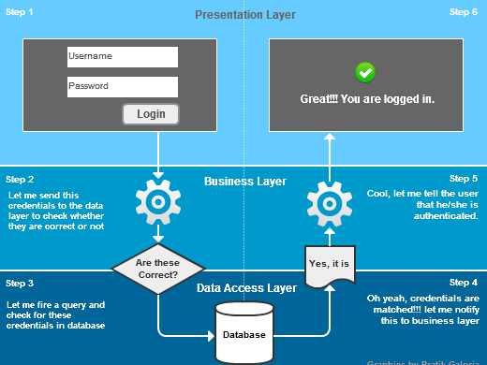

### Entity Relationship Diagram



1..1

send

manage

1..*

|  |  |  |
| --- | --- | --- |
|  |  | ADMIN |
| Pk | Admin_id |
|  | Fname |
| 1..* |  | Password |
|  | Phone_num |
|  | DOB |

|  |  |
| --- | --- |
|  | Contact |
| Pk | Contact_id |
|  | name |
|  | Email |
|  | Password |
|  | message |
|  | Gender |

Entity Relationship Diagram (ERD), a database design tool that provides graphical representation of database tables, their columns and inter-relationships. This ERD provided a sufficient information for database administrator when I was developing and maintaining database

Figure 3: shows an Entity Relationship Diagram of the system

|  |  |
| --- | --- |
|  | USERS |
| Pk | User_id |
|  | Fname |
|  | Email |
|  | Password |
|  | Phone_num |
|  | Gender |

|  |  |
| --- | --- |
|  | **PARKING** |
| pk | Parkid |
|  | Park |
|  | Plot |
|  | model |
|  | Num_plate |
|  | payment |
|  | email |
|  | Time_A |
|  | Time_D |

1..*

reserve

1..*

1..1

### Database Schemas

Below are the tables contained in the Online Parking Reservation system database: Table 3:describes the parking table

|  |  |  |  |  |
| --- | --- | --- | --- | --- |
| Column name | Data type | Description | size | Allow null value |
| Parkid | Int | Primary key for the table | 15 | no |
| Park | text | Name of the parking | default | no |
| Plot | text | Name the parking space number | default | no |
| Model | text | Name the vehicle model | default | no |
| Num_plate | int | Indicate the vehicle number plate | 9 | no |
| Payment | float | Indicate the amount paid | default | no |
| Time_A | timestamp | Date and time of the client arrive in parking space | default | no |
| Time_D | timestamp | Date and time of the client departure from parking lot | default | no |

Table 4: describes the user table

|  |  |  |  |  |
| --- | --- | --- | --- | --- |
| Column name | Data Type | Description | Size | Allow null value |
| User_id | int | Primary key for the table | 20 | no |
| Fname | text | The first name and the last name of the user | default | no |
| Email | text | The email of the user | default | no |
| Password | text | Password of the user | default | no |
| Phone_num | int | The phone number of the user | 12 | no |
| gender | varchar | The gender of the user | 6 | no |

Table 5:describes the Admin table

|  |  |  |  |  |
| --- | --- | --- | --- | --- |
| Column name | Data Type | Description | size | Allow null value |
| Admin_id | int | The primary key of the admin | 12 | no |
| username | text | Username of the admin | default | no |
| Password | text | Password of the admin | default | no |
| Phone_num | int | Phone number of the admin | 12 | no |
| DOB | date | The date of birth of the admin | default | no |

Table 6: describes the contact table

|  |  |  |  |  |
| --- | --- | --- | --- | --- |
| Column name | Data Type | Description | size | Allow null value |
| Contact_id | int | The primary key of the contact | 12 | no |
| Name | text | The name of client or the user who want to send a feedback | default | no |
| Email | text | The email of user who want to send a feedback | default | no |
| Purpose | text | The reason of sending a feedback | default | no |
| Message | text | The message which needed to be delivered | default | no |

The researcher describe Results of Analysis, Results of Implementation, Results of Testing, Achievements of the project, Limitations of the project

## Results of Analysis

Figure 4: shows the pie chart for number of Clients who book the parking online

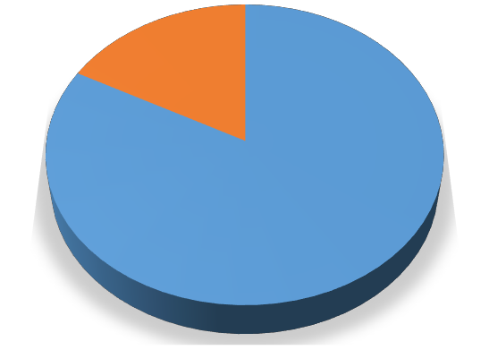

**Client who reserve a parking**

**17%**

**83%**

reserve

not reserve

researcher find that the average of the client who reserve the parking online was 83% whereas the client who did not reserve online was 17%.

### Results of Implementation

The Researcher found out that it should have web interface where User of the system (Clients/Employees /system admin) can logon and register, interface where clients Can reserve a parking, can view parking status. Interface where The employee can book a parking for the client, can cancel a booking, can update and also can delete the client .system admin can manage all users of the system such us employee and Clients .manage the parking lot.

Figure 5: shows the interface of system login

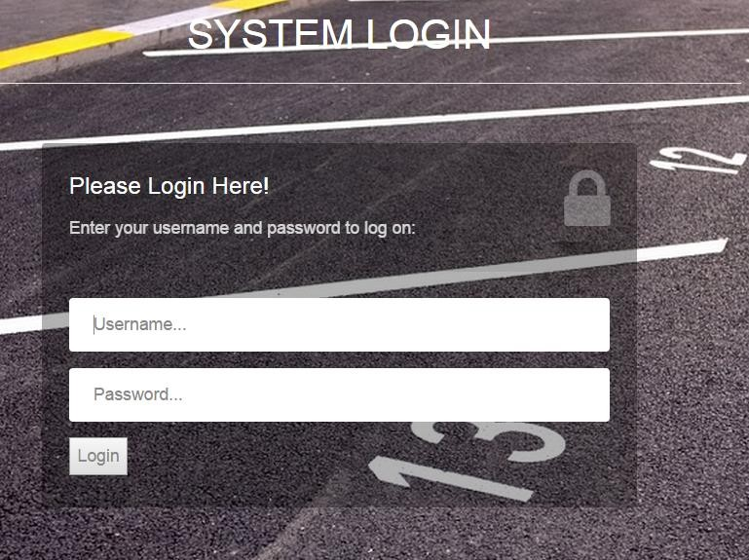

## Results of Testing

Cross browser testing was done by the researcher to ensure that the web application looks the same in major browsers that is Google chrome, Mozilla Firefox, Opera and Internet explorer.

The web project is consistent (looks exactly the same) in Google chrome, Mozilla Firefox and Opera but the looks vary slightly in internet explorer.

Figure 6: shows the Web application in Mozilla Firefox

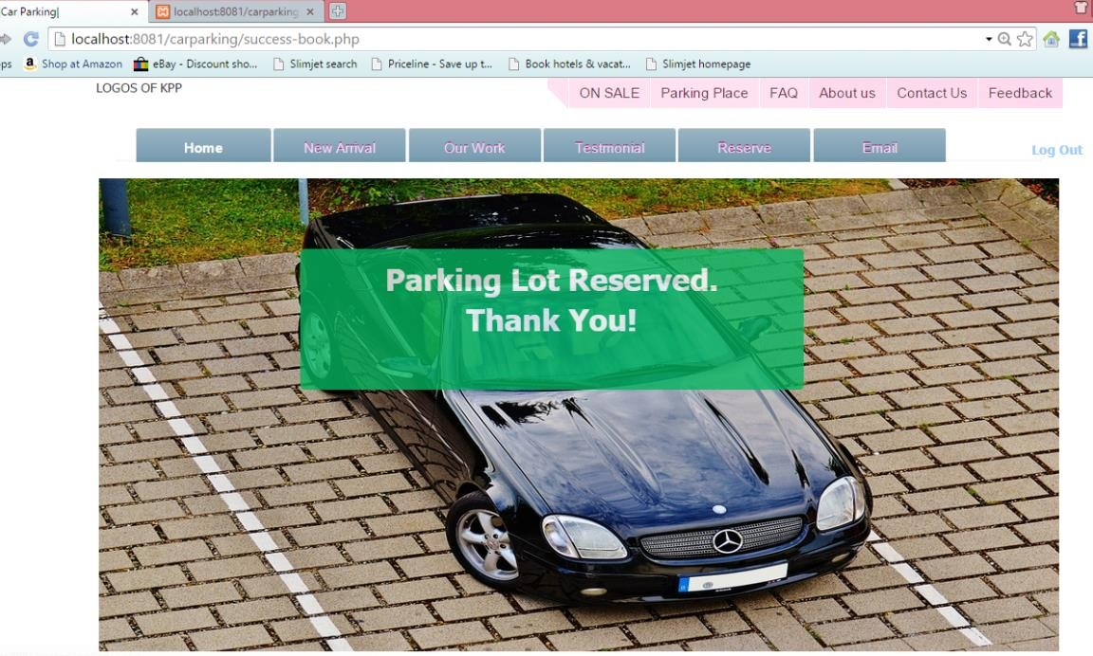

## Achievements of the project

* + - * Clients can create accounts on the system through registration **.**
        + System Administrator can manage the Employees by creating for them the account
* Employees are able to book the parking for the client
  + - * + Clients can view the parking available and reserve parking lot online.

System Administrators can manage the parking lot, transaction and also he can manage the client.

System Administrators can efficiently and effectively manage all the users on the application and roles.

* The chances of vehicle getting damaged due to improper parking are considerably reduced

### Limitations of the project

* Since this project is for the final project the credit card is not working properly
* Web application is not fully responsive (scaling down nicely according to different devices).

# Chapter Five

**Summary, Recommendation and Conclusion**

## Introduction

This chapter discusses about what has been done, recommendations on the system’s operations and the conclusions that are to be made regarding the system’s functioning in the current status and that of the future where some improvements are to be made on the system

* 1. **Summary**

This project was aimed to Improve on the current Vehicle Parking Reservation systems by creating Online vehicle reservation system which enables the client/driver to book parking space online

The existing vehicle parking reservation system was file based where customer pays cash at the receptionist then a receipt is given to the customer .this process was tiresome at kyebando people’s park. OVPRS enables drivers to locate and reserve a parking place online through accessing it on web platform where client login then she/he start process of booking a parking

## Recommendations

* + - Researcher recommend that the system be used by other parking companies because the researcher believes that the system can effectively and efficiently display the parking lot available, can allow clients, employee to reserve a free parking lot available.
    - Researcher recommend that more research should be done such that the vehicles detail should able to be scanned during entering in the parking place.
    - More research should also be done to extend this project to include tracking vehicle by using cctv camera for the purpose of maintaining the security.
    - The Researcher recommend that through making the web application more responsive the client will be able to reserve the parking lot on mobile devices easier.
    - The researcher recommend that any module that are not captured in a proposed system will be included during the system upgrade due to the time factor(for example:online payment module,etc)

## Conclusion

Online vehicle parking reservation system improves the existing system since we are in computerized world. With this new system is mandatory, it enables the user of the system (client, employee, System administrator) to reserve a parking lot online and this reduces the wasting of time of the clients looking for where to park, increase the safety of the property since the parking lot is numbering.

# References

Delmatic. Parking Management Systems. Available: [http://www.delmatic.com/systems/parkingmanagement-systems.](http://www.delmatic.com/systems/parkingmanagement-systems) Last accessed 4th Avril 2016

AsureSpace™ Workspace Manager Car Parking Management System. Car Parking Management System. Available: <http://www.asuresoftware.com/asure-space/workspace-> manager/parking-spacemanagement-system/car-parking-management-system-overview Last accessed 20 Feb 2014.

Aurecon Australia Pty. Ltd. (2013), Parking Spaces for Urban Places: Car Parking Study - Technical Report, Aurecon Australia Pty. Ltd., Adelaide, South Australia

Kianpisheh, A., Limtrairut,P. and Keikhosrokiani, P. (2012). Smart Parking System (SPS) Architecture Using Ultrasonic Detector. International Journal of Software Engineering and Its Applications. 6 (3), 51-58.

Shaheen et al., (2005); Chinrungreung et al., (2007).Online Reservation Parking System (ORPS)

Shem, S, S.Park and S.Hong (2006), Network Security.parking management system using Zigbee (chap 6 ,p131-137)

Planning SA (2001), Planning Bulletin: Parking provisions for selected land uses (Suburban Metropolitan Adelaide), Department for Transport, Urban Planning and the Arts, Government of South Australia, South Australia

Loucopoulos, P., & Karakostas, V. (1995). System requirements engineering: McGraw- Hill, Inc.

# Appendices

## Appendix 1: The project estimate.

|  |  |  |
| --- | --- | --- |
| **NO** | **ITEM** | **AMOUNT** |
| 1 | Lap Top | 2,500,000/= |
| 2 | Transport | 40,000/= |
| 3 | Internet | 50,000/= |
| 4 | Accommodation | 50,000/= |
| 5 | Meals | 500,000/= |
| 6 | Software | 60,000/= |
| 8 | Airtime | 20,000/= |
| 9 | **TOTAL** | **3,220,000/=** |

**Appendix 2: Project work plan schedule (2016)**

|  |  |  |  |  |  |
| --- | --- | --- | --- | --- | --- |
| ACTIVITIES | MAY | JUNE | JULI | AUG | SEPT |
| Background of the study |  |  |  |  |  |
| Problem statement |  |  |  |  |  |
| Objectives of the study |  |  |  |  |  |
| Research questions |  |  |  |  |  |
| Literature review |  |  |  |  |  |
| Methodology |  |  |  |  |  |
| System Implementation/Testing |  |  |  |  |  |
| Documentation |  |  |  |  |  |
| Presentation |  |  |  |  |  |
| Submission |  |  |  |  |  |

### Appendix 3: Screen shot for the interface of system administrator where the managing users are taken place

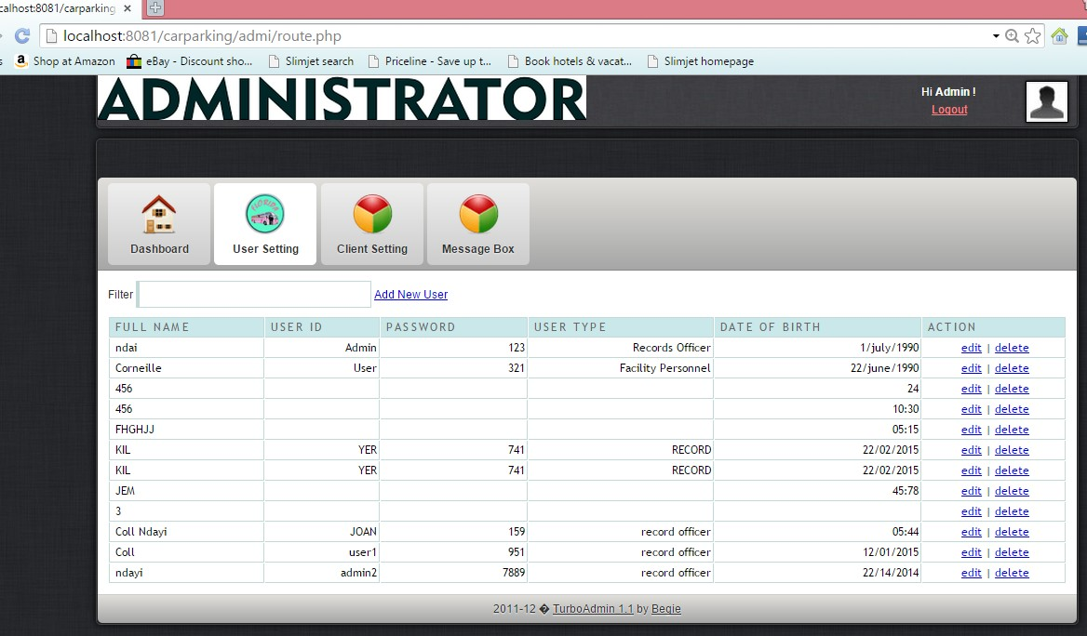

**Appendix 4: Sample code for user sign up in back end (php)**

<?php

require('inc\dbcon.php');

// If the values are posted, insert them into the database.

if (isset($_POST['name']) && isset($_POST['password'])){

$name = $_POST['name'];

$email = $_POST['email'];

$password = $_POST['password'];

$phone = $_POST['phone'];

//check existence

$sql="SELECT * FROM users WHERE email='$email'";

$result=mysql_query($sql);

// Mysql_num_row is counting table row

$count=mysql_num_rows($result);

// If result matched $myusername and $mypassword, table row must be 1 row if($count==1){

echo "User exists, please use log in."; exit;

}

else

{

$jdate=getdate();

$status="Active";

$query = "INSERT INTO `users` (name, password, email,phone,joindate,status) VALUES ('$name', '$password', '$email', '$phone', '$jdate', '$status')";

$result = mysql_query($query); if($result){

//REDIRECT

header('location:success-sign-up.php');

exit;

}

}

}

?>

## Appendix 5: Sample code for user sign up in front end

<link rel="stylesheet" type="text/css" href="inc/css/structure.css">

<link rel="stylesheet" type="text/css" href="css/mystyles.css">

<link rel="stylesheet" href="css/style.css" type="text/css" />

<link rel="stylesheet" href="login/css/style.css">

<h2 style="background-color:#000000" align="center" style="font-size:medium">Sign Up</h2>

<hr/>

<fieldset style="background-color:#FFCCFF">

<form action="process-sign-up.php" method="post">

Full Name:<br><input type="text" id="FullName" name="name" required pattern="(^[a- zA-Z]+$)"title="Your Name" placeholder="Your Name" maxlength="31" required /><br>

Email:<br><input type="text" id="FullName" name="email" required pattern="(\w+([-

+.']\w+)*@\w+([-.]\w+)*\.\w+([-.]\w+)*)" placeholder="Your Email" maxlength="31" required

/><br>

Password:<br><input type="password" id="FullName" name="password" required pattern="(^(?=.*\d).{4,8}$)" title="Please enter the correct format"placeholder="Your Password" maxlength="10" required /><br>

<h5>Password must be between 4 and 8 digits long and include at least one numeric digit</h5><br>

Phone Number :<br><input type="text" name="phone" id="FullName"required pattern="[0](\d{9})|([0](\d{2})( |-|)((\d{3}))( |-|)(\d{4}))|[0](\d{2})( |-

|)(\d{7})|(\+|00|09)(\d{2}|\d{3})( |-|)(\d{2})( |-|)((\d{3}))( |-|)(\d{4})" title="phone number" placeholder="Your Phone Number" maxlength="13"/> <br>

Gender:<br> <select name="gender" class="cjComboBox" >

<option value="Male">Male</option>

<option value="Female">Female</option>

</select><br>

<input type="submit" id="LogIn" value="Sign Up">

</fieldset>

</form>

30

[View publication stats](https://www.researchgate.net/publication/324517934)